Hartford HealthCare – Israel Health Tech R&D and Pilot Program Call for Proposals
The Israel Innovation Authority and Hartford HealthCare Corporation (HHC) invite interested Israeli companies to submit applications to collaborate in pilot and R&D healthcare-related technology activities with HHC.
HHC and the Israel Innovation Authority are seeking to advance healthcare by helping Israeli companies get the evidence and assistance they need to fine-tune their development and to enter and be successful in the United States’ healthcare market.
HHC would serve as a real-world living laboratory for the Israeli companies to test and improve an existing process, service, or product; or to apply a new process to health care for the first time.
The goal of this collaboration is to accelerate the availability of medical innovations to the public, introduce Israeli healthcare technology to the U.S., and advance the development and deployment of discoveries for the benefit of patients everywhere.

The Israel Innovation Authority provides resources to aid technology advancement for Israeli companies.
HHC is Connecticut’s (CT’s) only fully integrated health system that is leading the transformation of care in the 185 towns and cities we serve by providing high-quality, coordinated care that touches the lives of 17,000 people across CT and beyond. HHC has more than 360 access points (i.e., acute care hospitals, ambulatory care and surgical centers, and physician services). HHC has more than 30,000 colleagues and operating revenue of approximately $4.3 billion. HHC’s goal is to be number one for patient/customer experience in the Northeast of the United States by 2023 (#123).
By integrating multi-specialty providers into one system of healthcare delivery, HHC can offer coordinated care across the continuum, achieve economies of scale, make care more affordable, and focus on consistent, high-quality care.
HHC’s Innovation Organizing Principles
Healthcare is changing at an increasing velocity and organizations that do not innovate will be left behind. HHC is committed to supporting an efficient and seamless healthcare innovation ecosystem to accelerate ideas to market and an environment where all stakeholders can extract value.
HHC is applying emerging innovative technologies to create transformative patient and provider experiences, redefine excellence in quality and safety outcomes, decrease friction to access and delivery of care, diversify revenue, and manage costs effectively. Innovation is embedded in HHC’s DNA with the extraordinary resident intellectual property of employees and assets. HHC’s aligned leadership and unique culture, coupled with an agile and lean-driven operating model have a force-multiplying effect on innovation and transformation.
HHC’s innovation goals include:
- Align and drive HHC’s strategic priorities
- Create a differentiated value proposition and competitive advantage
- Create an efficient and relatively frictionless healthcare innovation ecosystem and platform to accelerate ideas to the market
- Create an environment where all stakeholders can extract value
- Diversify revenue sources
- Incubate and develop new healthcare companies
- Foster and grow a culture of innovation and attract world-class entrepreneurs
- Contribute to economic development in the City of Hartford and the State of CT

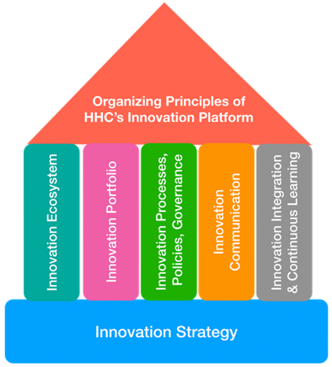
HHC’s innovation strategy to achieve its goals is built on 5 foundational pillars:
- Innovation Ecosystem (assets and stakeholders)
- Innovations Portfolio (new products and companies)
- Innovation Processes, Policies, Governance
- Innovation Communication
- Innovation Integration and Continuous Learning
Every pillar’s success is reinforced by the other pillar’s success. Each pillar is being developed with measurable key results.

HHC’s Innovation Ecosystem
The following HHC key strategic innovation assets and capabilities serve as a “sandbox” environment for emerging innovative digital health solutions and can serve as a resource for Israeli companies:
- The Center for Education, Simulation and Innovation (CESI): CESI is one of the country’s premier simulation centers and would be available as a resource to Israeli companies, helping them pressure-test proposed advancements in healthcare delivery and healthcare operations.
- Care Logistics Center: HHC has created a “command center” to manage all patient movement/transfers within and between its system’s seven acute care hospitals. The goal of this center is to ensure that the right level of care is provided to each patient at the right location. This center uses state-of-the-art technology to manage the flow of patients and would also serve as an ideal place for digital health companies to determine and test the compatibility of new healthcare analytics, artificial intelligence (AI), and IoT-enabled technologies with a healthcare delivery system.
- HHC Community Network: HHC Community Network is the largest home care nursing and hospice agency in CT. As part of a coordinated population health plan, home care is ripe for innovative digital and virtual health strategies. Experts from this unit will help emerging companies understand the specific needs of at-home patients and how to adapt the technology for a non-acute care clinical environment in order to maximize the benefit to patients and providers.
- Health Analytics: HHC has made significant capital investments in information technology (IT) and analytics, including an integrated electronic health record (Epic), and in advanced next-generation analytic capabilities (AI, predictive and prescriptive). The analytics and IT teams are available as potential collaborators for startups to provide the critical interface between technology platforms and high quality effective and efficient patient care.
- Research: HHC’s Research Administration program is organized to provide optimal services and oversight to conduct medical research at its institutions. The goal is to support and facilitate the growth of research and offer patients access to new and novel treatment options. To that end, the program has developed a centralized infrastructure to meet the needs of research investigators across the HHC system including an Institutional Review Board.
- Clinical Institutes: HHC has developed a patient-centered approach to delivering care, focused on clinical institutes. Physicians of multiple sub-specialties come together in the Institutes to provide cutting-edge coordinated care, which enhances quality, safety, and patient experience. The Institutes are charged with investing in continuous innovation and research to advance care and will be ready to serve as key sources of clinical feedback for emerging startups looking to improve patient outcomes. These Institutes include:
  - Heart and Vascular Institute
  - Bone and Joint Institute
  - Ayer Neurosciences Institute
  - Cancer Institute
  - Tallwood Kidney and Urology Institute
  - HHC Behavioral Health Network – the largest provider of mental health services in CT
- HHC Medical Group (HHCMG): HHCMG is a multi-specialty group encompassing physicians in more than 30 specialties in convenient offices across Central, Eastern, and Southwestern CT.
- Integrated Care Partners (ICP): ICP is a physician-led, clinically integrated healthcare network with the mission to assist its members in providing the highest quality care at the most reasonable cost for their patients in the current, rapidly changing healthcare environment.
- HHC Pharmacy: The HHC Specialty Pharmacy Program is an outpatient pharmacy program dedicated to providing patients with the support necessary to manage complex medication regimens. Pharmacists and liaisons work with an individual’s healthcare providers to ensure his/her specialty medication needs are delivered accurately and on time, intending to provide the patient with fully integrated pharmacy services and the highest quality care.

In addition to its innovation strategic assets, HHC recognizes that a vibrant entrepreneurial and innovative healthcare ecosystem involving multiple stakeholders (academic and teaching institutions, government, entrepreneurs, intrapreneurs, corporate, and risk capital) is key to achieving its goals. The virtual assembly of key strategic innovation assets (graphic below) enhances HHC’s own “sandbox” to accelerate transformative products and business development opportunities to impact. An example of this was HHC’s leadership and participation in a MedTech initiative.

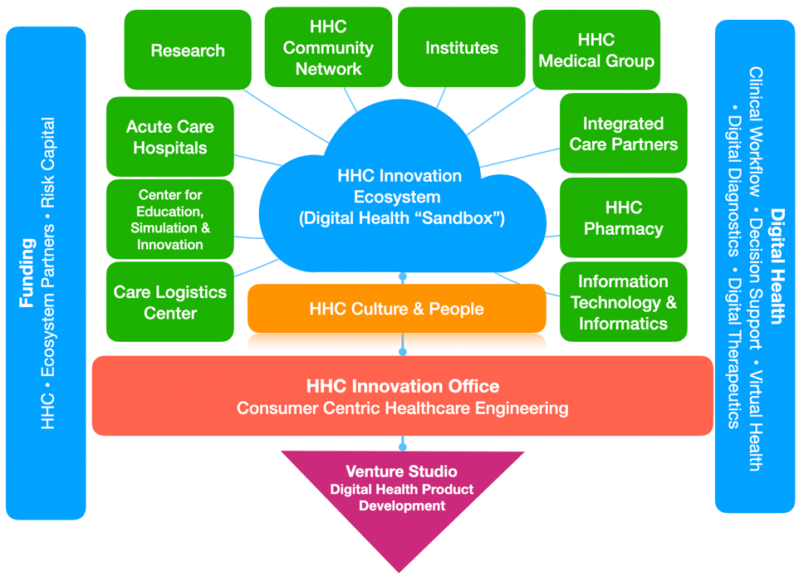

- Digital Health Accelerator CT: HHC was the anchor institution partner in a digital health accelerator that was part of the CT grant-funded initiative Innovations Place – to foster innovation, economic development, and job growth in the Hartford Region, focused on MedTech innovation. This was a public-private initiative in partnership with Trinity College, in Hartford, and the UConn School of Business. In February 2020, a cohort of 10 startup companies completed the 13-week program, and HHC is now working with a number of these companies to conduct pilots and clinical research studies, and provide continued mentorship.

Focus Areas:
The digital health themes of interest to HHC include:
- Clinical workflow
- Decision support
- Digital diagnostics (proactively track and manage own conditions)
- Digital therapeutics (data analytic tools to allow for automatic, fast and affordable medical diagnostics)
- Precision medicine
- Virtual health-remote monitoring (keeping patients healthy at home)

HHC is committed to precision innovation that aligns and drives one or more of the following priorities for HHC:
- Patient/customer experience (#123)
- Quality and safety
- Healthcare access
- Clinical workflow
- Operational efficiency
- Revenue diversification
- Cost mitigation

Application Process

Phase 1

Deadline for Expression of Interest (EOI) form submissions: 14/11/2022
The Israel Innovation Authority will invite selected Israeli companies to phase 2.
Phase 2
By 20/02/2023 the Israel Innovation Authority will invite selected Israeli companies to phase 2.
Deadline for full submissions: 21/06/2023

Supported activities may include: piloting, testing (of different kinds; including in real-world conditions), validation, trials, performance verification, device iteration, product and interface customization, pre-pilot activities, R&D activities needed for the pilot, optimizing the clinical use of a given technology/product, identifying the parameters of the product/technology and potential use cases, optimizing user interfaces, etc.

What support do the Israel Innovation Authority and HHC offer?
Successful Israeli applicant companies will receive funding from the Israel Innovation Authority. The Israel Innovation Authority can support R&D performing companies, registered and operating in Israel, with a grant of up to 50% of the approved R&D and Pilot Expenses Budget, according to its regulations and procedures. The Israeli companies must follow Israel Innovation Authority's rules and regulations, as described in the Hebrew website: https://innovationisrael.org.il/international/rnd

When a project eventually results in sales of a product, service, or process, the financial support must be repaid in royalties to the Israel Innovation Authority according to its regulations. In general, royalties are paid at rates beginning at 3% of sales, depending on various criteria. Royalties are payable until 100% of the amount of the grant has been repaid with interest as provided in the applicable regulations. If the project does not result in sales, no repayment is required.

HHC would provide assistance for the project and make it accessible through an applicable agreement with the selected Israeli companies. In the case of a pilot project, where no IP is shared, up to 10% of the project budget could be used to pay HHC for its services. In the case of a joint R&D project, where IP is shared, the costs of HHC could not be funded by the IIA.
HHC may provide in-kind services, expertise, and/or use of facilities. Examples for such in-kind support can include:
- Internal champions and mentors to co-develop and identify the parameters of the product/technology and potential use cases;
- Assistance with testing, validating and creating efficient processes for Israeli companies to test their technologies, products, services, and devices in a real-world living laboratory of a top US health care system;
- Access to HHC’s clinical, administrative and leadership staff, across a variety of care settings (i.e. inpatient, outpatient, ambulatory, urgent care, rehabilitation, home care, etc.);
- Opportunity to generate peer-reviewed scientific data to validate the effectiveness of the product;
- Assistance with regulatory and commercial aspects of the US health care marketplace;
- Introductions and engagement with other healthcare-related entities (e.g. healthcare systems/hospital and insurers);
- Drive Israeli innovation into the US healthcare market;
- Enhance intellectual capital of Israeli technologies, products, services, and devices;
- Ongoing refinement and validation of Israeli company technology beyond commercialization;
- Sourcing assistance for applicable products through an introduction to HHC-associated venture capital and private equity investment funds.

In exchange for some of the in-kind services, expertise, and/or use of facilities, HHC can require to be compensated by equity in the successful applicant company and/or royalties and/or revenue share of the commercialized products or services that are the subject of the project. Revenue management and the equity model will be underpinned by the collaboration agreement between HHC and the company.
An appropriate agreement between successful applicant companies and HHC will need to be signed as one of the first milestones during the project initiation.

Process and Timeline
Program launch | September 2022
Deadline for submission of Expression of Interest (EOI) | 14/11/2022
Health centers select shortlisted companies, IIA invites shortlisted applicants to submit full application | 22/02/2023
Deadline for full IIA online application | 21/06/2023
IIA funding decision & project launch | September 2023

Contacts

HHC  Candace Carlson  candace.carlson@hhchealth.org  Clare Cryar  clare.cryar@hhchealth.org  Barry Stein, M.D., VP and Chief Clinical Innovation Officer  Barry.Stein@hhchealth.org | Israel Innovation Authority  International Collaborations Division  InternationalCollaboration@innovationisrael.org.il

Support may vary subject to the health center discretion.

