Announcement:

12th German - Israeli Call for Proposals for Joint R&D Projects

Deadline for proposal submissions:
November 28th, 2019

Scope
Germany and Israel are announcing a Call for Proposals for joint R&D projects, focusing on developing innovative products and applications in all technological and application areas. Applicants are expected to develop ready-to-market solutions for products, technology-based services or methods which have strong market potential for Germany, Israel and Europe. Partners apply for their R&D project for a EUREKA label, a pan European network for market-oriented R&D.
ISERD and the German Federal Ministry for Economic Affairs and Energy (BMWi) will provide access to public funding for joint projects provided by The Innovation Authority and by BMWi’s ZIM program (Central Innovation Program for SMEs), respectively. Minimum requirement concerning the project consortium is the participation of at least one company of each of the participating countries.
The program is managed in cooperation and in line with the procedures of the EUREKA initiative. www.eurekanetwork.org/
ISERD and BMWi (supported by the EUREKA-Office, Bonn and the ZIM project management agency) will provide all necessary assistance to project partners during the project proposal, evaluation and monitoring phases. In addition, both ISERD and the EUREKA-Office will facilitate the EUREKA application process and acquisition of the EUREKA label for accepted proposals and will accompany the progress of the respective EUREKA projects.
Call Structure
The call invites partners to present joint proposals for industrial R&D projects till November 28th, 2019 according to the following procedures:

Project content and evaluation for national funding request
Expected project results will have to contribute to the development of commercial products, applications and / or technology-based services. The project proposals have to comply with the following guidelines:
- The partners should include at least one Israeli and one German commercial company (though participation of research institutes/universities is welcome as additional participants or subcontractors according to each country’s funding regulations).
- Companies and/or academia from other countries may also participate. These partners’ participation follows EUREKA participation and financing rules and procedures and the funding regulations of these partners’ countries of origin.
- The project should have an obvious advantage and added value resulting from the cooperation between the participants from the two countries (e.g. increased knowledge base, commercial leads, access to R&D infrastructure, new fields of application, etc.).
- The project should demonstrate the contribution of the participants from both countries
Any partner whose cooperative R&D project is consistent with the aforesaid criteria can apply to the present announcement in accordance with the national laws, rules, regulations and procedures in effect.

Submission and approval procedures
The completed EUREKA application form www.eurekanetwork.org/project-application (in English) should be submitted to ISERD in Israel and to the EUREKA-Office in Germany simultaneously by November 28th, 2019. The forms have to be legally signed by all participating companies. The signatures must be scanned and sent electronically together with the EUREKA application form. The final EUREKA status is only granted if the funding of all project partners has been secured.
The EUREKA project application will be screened and evaluated by ISERD in Israel and the German EUREKA Office.
Simultaneously all partners have to submit in addition their funding applications according to national procedures. Companies should contact the national funding organizations before submission! (See national contact information at the end of the document).
- Israeli partners will be invited to submit in addition and at the same time as the short project outline their funding applications to the Innovation Authority using this link: בקשה הגשת
- A provisional consortium agreement among project partners is needed at the moment of proposal submission in this phase.
- Submission to the Innovation Authority: 28th November 2019 till 17:00.

Each country will fund its eligible participants within the EUREKA framework. Funding conditions and eligibility criteria vary between participating countries. Up-to-date information in relation to bilateral projects in education and research is available http://www.bmbf.de/en/1531.php.
As a summary, main aspects of the criteria are explained below
Germany
All German SMEs with up to 499 employees (or consortia of such enterprises) which perform R&D to develop an innovative product, process or technological service – also in cooperation with a research institution/university – have the right to apply. There are no restrictions to specific technologies or branches. More detailed criteria can be found on the ZIM website (www.zim.de/ZIM/Navigation/DE/Foerderangebote/Kooperationsprojekte/kooperationsprojekte.html - in German). The application has to be in line with the ZIM regulation, e.g. it has to be in the German language. Support is rendered in the form of a conditional grant amounting up to 55% of the project costs, which are restricted to 380,000 € per industrial partner.
The final approval is made by the ZIM project agency. It is possible to begin a research project at the applicant’s own risk after receiving a confirmation of the receipt of the funding application from AiF Projekt GmbH. We recommend contacting AiF Projekt GmbH before the application to clarify open questions and to hand in a project sketch up until 6 weeks before deadline. German research institutes/universities are accepted as additional partners according to the rules available on the ZIM website.
The proposal form is available on:
www.zim.de/ZIM/Navigation/DE/Formularcenter/formularcenter.html

Israel
An Israeli R&D performing company which initiates a single or multi-year program that will provide know-how, processes or methods for the manufacture of a new product, application, technology-based service or process is eligible to apply. The product must have a sizeable potential for export sales. Research institutes or other participants may apply as a subcontractor to a company. The support is in the form of a conditional grant amounting generally up to 50% (+ regional incentives for companies located in "development zone ") of the eligible R&D budget. Further details regarding grants and payment of royalties are available at the Innovation Authority web site:
https://innovationisrael.org.il/

Contacts in Germany:  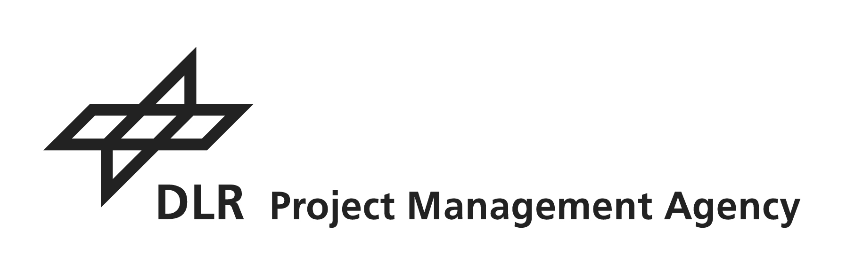 |  | 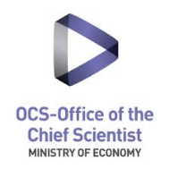  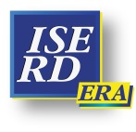  Contact in Israel:
German Aerospace Center  Project Management Agency  EUREKA-Office  Heinrich-Konen-Str. 1  53227 Bonn  tel. +49 228 3821 1335  e-mail: eureka@dlr.de  http://www.eureka.dlr.de |  | Uzi Bar-Sadeh  Israeli EUREKA NPC  ISERD  tel: +972 3-5118 185  e-mail: uzi@iserd.org.il  http://www.iserd.org.il
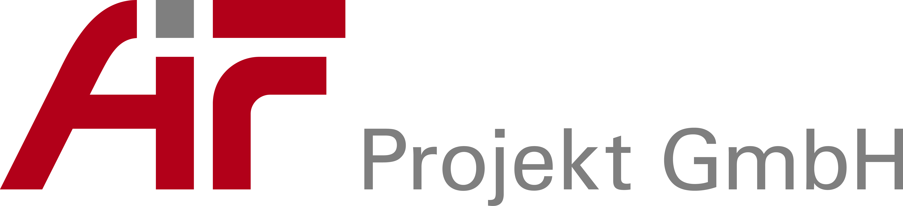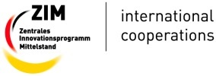

ZIM Funding Program
AiF Projekt GmbH
Project Management Agency
Georg Nagel
Tschaikowskistraße 49
13156 Berlin
tel. +49 30 48163 526
e-mail: international@aif-projekt-gmbh.de
http://www.zim.de

Published September 4rd, 2018

