18.05.2022
To:
Subject: Sandbox of Second Public Appeal for Promoting the Operation of Multi-Rotor, VTOL, and Unmanned Aircraft in Managed Airspace
Annex A: Rules of operation – abstract of company briefing document, used to document all knowledge included in Public Appeal 5185.
Annex B: Way of writing response
- Background:
  - Many technologies have come to fruition over the last few decades, including Distributed Electric Propulsion (DEP); affordable, accurate navigation capability relying on redundant GNSS satellite systems, ultra-high frequency electronic control, miniaturized sensors, etc. – all combined enable operation of innovative aircraft configurations including eVTOL, a wide variety of UAVs, and more.
  - Massive development has taken place in the operation of these aircraft worldwide.
  - High-level architecture for regulating a broad-based aircraft operation at an altitude of 122 meters above ground level (AGL) and lower (expected to expand in the future) for the common good. This activity is promoted in the USA (NASA, FAA, and various standardization efforts) and Europe (EASA, Eurocontrol, the SESAR 3 Joint Undertaking, and other initiatives in this context). The two major efforts (the American and the European) have adopted the same ASTM Standards, the difference in approach proving to be no obstacle to adopting the same Standards.
  - In Israel, until today the ‘ecosystem’ for the operation of small eVTOL and UAV aircraft (maximum takeoff weight, MTOW, up to 25 kg) is promoted through the Israel National Drone Initiative (INDI), including the Ministry of Transport, Innovation Authority, Smart Mobility Administration, and Netivei Ayalon as the Initiative’s executive arm.
- Intent:
  - To define the ‘playground’ for support of the second Call for participation in Promoting the Operation of Multi-Rotor, VTOL, and Unmanned Aircraft in a Managed Airspace in the following dimensions:
    - What the proposers should know, and what challenges we will address on the regulatory level.
    - On the geographical level.
    - On the ‘rules of the game’ level, regarding safety separation rules concerning air traffic.
    - On the rules of the game regarding the reduction of risks towards the ground.
    - As far as requirements from the operating companies, aircraft and operators ("pilots") are concerned, as well as companies dealing in coordinating flights and providing services to the managed airspace (both in airspaces to be defined by the CAAI as U-SPACE and interfacing with the existing airspace operated by the Israel Airports Authority and/or Air Force).
    - On the level of interfaces with the existing players in Israel, including the Civil Aviation Authority of Israel (CAAI); the Israel Airports Authority; the Israeli Air Force (including, operationally, Control Units Command, Traffic, Synchronization, Air Control Units; Air Control Center, soft (electronic) defense systems, control towers, and various relevant squadrons/units); relevant force build-up bodies (weapons systems, UAV Administration under the Ministry of Defense, MAfAT, Magen Program Administration, various research units within MAfAT, etc.); Army Headquarters and Front Commands, divisions, brigades, and battalions – in connection with the operation of eVTOLs and UAVs, Israeli Police, Home Front Command, United Hatzalah, Environmental Protection, Israel Nature and Parks Authority, municipalities, and other organizations in possession of Drones/ UAVs
    - On the operational level.
- Policy:
  - As part of the "Call for Proposals" for Promoting the Operation of Multi-Rotor, VTOL, and Unmanned Aircraft in Managed Airspace, the intention is to make considerable progress in the following parameters:
    - Range of aircraft flight – from about 5 km to about 150 km.
    - Possible payload – from about 3 kg to about 15 kg (with eVTOL / UAV) and up to about 1/2 ton of usable cargo with eVTOL platforms.
    - Supporting regulation – ability to operate in all types of airspace in Israel.
    - Significant expansion of possible applications.
    - Considerable increase of potential vertical businesses, end-users, the scope of applications, and business models.
  - Advancement of ‘air taxis’ – aircraft capable of carrying paying passengers; quiet aircraft, independent of runways (vertical takeoff and landing), less noisy, cheaper to operate, and non-polluting – all compared to helicopters.
  - All relevant activities shall be carried out under the Israeli Aviation Law, regulations, and Civil Aviation Authority (CAAI) permits.
  - As far as possible, innovative matters will be handled under a regulation envelope dependent on European and/or American regulation to nurture companies towards becoming global players. By default, in any case of discrepancies, the intention is to follow the European Union regulation (contingent upon CAAI approval).

Annex A: Rules of operation:
- The rules of operation shall be consistent with the Aviation Law, the Israeli Regulations, the Aeronautical Information Publication, and Israeli regulations. Wherever operation also complies with foreign regulation, the intent is to follow, as practically possible, European and/or American laws. As a default, European regulation should be followed in any discrepancy.
- As practically possible, the rules of operation shall be according to the assemblage of conclusions drawn from the activity of Call for Participation 5185 and the operational experience of the National Drone Initiative / NAAMA Initiative (Israel Urban Air Mobility Initiative) over the past two years.
- Rules of operation:
  - The geographical playing field
    - We intend to expand our geographical coverage so that more ‘bubbles’ and flight spaces in Israel will undergo an air assessment and coordination with all relevant players, including the Israel Airports Authority, the Air Force, the Israeli Police, local authorities, and control towers, etc.
    - Spaces in which the National Drone Initiative has already made U-Space compatible flights include Hadera, Herzliya, Ramat Hasharon, Tel Aviv, Yeruham, Jerusalem, and Beersheba.
    - In addition, as a default, the present Public Appeal shall include:
      - Flights in the space under the TMA according to the Eitan Procedure (in other words, flights in which altitude is limited so that between the drone and Ben Gurion Airport, there is a shading of buildings in such a way that enables flying without the need to coordinate with BGA, under all the terms defined in the Eitan Procedure, particularly USSP monitoring).
      - Flights adjacent / in proximity to/within the control area (CTA) of civilian airfields such as Haifa, Mahanayim, etc.
      - Flights adjacent / in proximity to/within the control area (CTA) of military airfields.
      - Long-range flights between ‘UAV bubbles,’ including but not limited to the transport of medical equipment and medications from Ashdod Port or logistical center to hospitals in central or northern Israel (Ziv, Poriah, Hagalil) to the blood bank in Haifa and/or Rambam Medical Center). These routes shall be chosen, among other things, to develop the regulation required for transition between different types of airspace.
  - Quantity of flights to which the proposers are committed.
    - The initiative shall conduct a week of flights each calendar month as a default.
    - The operating companies shall price at least 50 flights for each week of operation.
  - Mandatory rules and documents.
    - According to the Call for Proposals.
    - Preference will be given to proposers showing compliance with the Companies Briefing Document of Public Appeal 5185 and "Lessons learned" from the sessions already flown.
    - As a default, proposers should present compliance to EASA Regulation 664, NPA 2021-14 (derived from 664), the ASTM standards cited in them, and accumulated knowledge of Public Appeal 5185.

  - The architecture of IT systems:
    - The architecture planned for the airspace is defined as a USSP U-space: 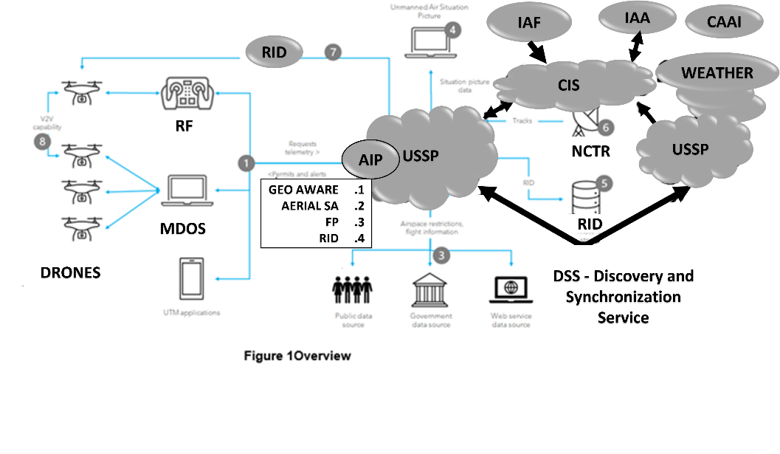
      - The working principle for managing traffic in the controlled airspace is based on collecting data from the aerial activity and publishing the common aerial picture through IT systems (interfaces between computers). In a certain sense, this approach replaces the human-operated radar and air control systems (at very low altitude, where CAAI declared the establishment of a managed airspace/U-SPACE).
      - The aircraft (drones in the drawing) are operated by a holder of an Air Operator Certificate (AOC)—this might change if UAV Regulations will come to effect, expected towards the end of 2022 (The new regulation is expected to allow operating drones under 25 kg MTOW – fly without the need for AOC certificate.
      - The aircraft manufacturer/integrator is responsible for the engineering aspect of designing hardware and software, operation and maintenance instructions, capable of producing engineering reports in all relevant areas to support licensing, receive permits (on the operational level, specific operation) to enable ongoing commercial operation of the UAV fleet.
      - The systems must obtain a special airworthiness certificate – ‘special permanent authorization for UAV system’ from CAAI, pursuant to the following regulations.
(*) The administration may give an unmanned aircraft a special permanent authorization for flight, provided that the following two conditions are fulfilled:
(1) Requirements of engineering proof of airworthiness as instructed by the administration.
(2) Aircraft is in a state of fitness for safe operation according to administration test.
      - The aircraft must be following that stated in Article 6 of EASA Regulation 664 and NPA 2021-14.
      - Aircraft include:
        - Flight controller – deals with flying within the defined safety envelope regarding speed, maintaining the aircraft’s position in space, its location, compliance with limitations of yaw, pitch, and roll angles, preventing loss of control under wind shear, etc. This component of architecture is external to the Initiative, usually the manufacturer’s responsibility and subject to the supervision and authorization of CAAI / engineering.
        - Mission computer – the airborne computer that enables giving the aircraft navigation instructions, monitoring various parameters, relaying back parameters of energy, sensor output, etc.
        - RF Controller – the instrument that enables flying with ‘sticks’, translated into RF commands that constitute command signals to the UAV itself (some of the devices lack a RF controller).
        - RID – independent identification means designed to serve all organizations and agencies authorized to receive data (such as Air Force, Police, Airport Authority), and give the public the ability to complain about specific flights using RID in ‘broadcast’. In addition, prevent unauthorized use of drones, inter alia, since every drone has an RID (a drone without one will automatically be suspicious); use of anti-tamper software, etc. As defined in standard:
ASTM F3411-19 ‘Standard Specification for Remote ID and Tracking
There is nothing to preclude the means from forming part of the air vehicle components, provided the operator proves that the operating company is unable to change the device parameters, especially the CAAI given registration "call sign" (4X-***).
      - MDOS – command and control system belonging to the aerial operator. The MDOS performs mission planning with consideration for both external (restricted airspace/ no fly zones) and internal constraints (energy in the battery). Submitting a request for flight clearance from the USSP; receipt of flight clearance (or rejection); injection of mission into aircraft and tracking of aircraft once airborne, including ability of single operator to operate multiple aircraft; keeping ‘situation awareness’ of drones while airborne etc. with continuous reporting to USSP and receipt of instructions in real time.
      - USSP – the system supporting provision of services to all aerial operators within the U-space. This system, at the very least, provides four mandatory services: geographical awareness, aerial picture of air traffic relevant to the customer, managing requests for flight clearance, and RID (network and broadcast). As an aspiration, full roaming ability shall be permitted. In other words, an aerial operator who has chosen a USSP will be able to remain with it wherever the said USSP provides service, and responsibility for synchronization between the various USSPs will rest with them, (or jointly with the CIS, DSS if present) like traveling abroad with a mobile phone and personal SIM, with the user continuing to be serviced transparently.
      - CIS (Common Information Service) – the entity in charge of the information services themselves. Information flow to/from the other bodies (Air Force/IAA/Police etc.), also able to assume responsibility for exchanging a portion of the information with the USSP (such as no fly zones) (as defined in EASA Regulation 664 and NPA 2021-14). Under the European Standard a control architecture without CIS is also optional.
    - The architecture of the airspace of manned aircraft in Israel can be found in Aeronautical Information Publication and in CAAI, Airport Authority and Air Force publications.
      - In general, functions connected with operating the aircraft, flight control, and communication to and from the aircraft are under charge of the aircraft manufacturers and therefore irrelevant to the present Public Appeal.
      - The operating principle for managing air traffic of manned aircraft is based on radar and/or IFF (Identification, Friend or Foe) and/or ELINT (electronic intelligence); thus, the ‘aerial picture’ is presented to air traffic controllers whose job is to manage air traffic safely. As a default, given that pilots and/or UAVs adhere to the flight data dictated in the infrastructure and/or provided by air traffic controllers, safety margins are maintained.
      - In recent years, systems that enable pilots to keep safety margins are being introduced, including TCAS (traffic alert and collision avoidance systems, inside the cockpit) and ADS-B systems that automatically broadcast the location of the aircraft; thus, planes receiving these broadcasts can see the aerial picture within the aircraft.
      - Military aircraft are usually equipped with radar, IFF interrogator, and network-based identification devices, which enable pilots to maintain a certain aerial picture in their immediate surroundings, even when disconnected from the control.
      - As a default, air traffic is managed from air force control units, in areas where they have been granted this authority. The air force manages air traffic on the basis of ‘training areas’, ‘routes’, control tower supervision areas, etc.
      - In Israel, most of the airspace is managed by the air force.
      - In the civilian airspace, air traffic is managed by the relevant ACC and/or Tel Aviv/Southern Control (Airport Authority units). Traffic control is based, inter alia, on infrastructure such as routes, arriving and departure procedures to airports, and many other mechanisms. The main airspace managed by civilian mechanisms in Israel is located in the funnel of approach to Israel, west of and in the space above BGA and its surroundings – from the Mediterranean coast to the northern Dead Sea (including most of the airspace over the greater Tel Aviv and greater Jerusalem areas). In addition, a main civilian route exists from the northern Dead Sea to Eilat.
      - In certain limited areas, at low altitude, one may also fly according to CVFR rules; in other words, in a way that responsibility for preventing collisions rests on the pilots and not on air traffic controllers.
      - In certain limited areas, in well-defined bubbles and certain windows of time, one may also fly according to VFR rules; in other words, where flights are the sole responsibility of the pilots, and no control is required. In Israel, this component of aviation is very small, and limited in time and space.
      - In the vicinity of airfields, the airspace is managed by control towers rather than ‘regional control’ (Air Force control units and/or ACC of the Airports Authority, according to the particular region).
      - Warning: Interference with GNSS signal reception impairing the capabilities of operating and maintaining the location of UAVs is a common phenomenon in Israel.
    - The architecture of the ‘connection between worlds’ has not yet been determined and is, to a large extent, one of the main goals of this Public Appeal/ Call For Proposals.
  - Participating stake holders:
    - Israel Airports Authority (IAA)
    - ACC North, South, and Tel Aviv Control
    - Air control towers (BGA, Ramon, Haifa, Rosh Pina, etc.)
    - Flight approval center ("Modiin Tyse"@IAA).
    - Eurocontrol
    - Israeli Air Force
    - Control Units Command
    - Air Force Synchronization Center
    - Control units
    - Control towers at military air bases
    - Air Force "Magen" Administration
    - Civil Aviation Authority of Israel (CAAI) Professional departments: Aviation supervision (licensing of flight workers and airlines), aviation infrastructure (airspace, traffic control, airfields, and landing strips), and the airworthiness department (initial licensing of aircraft systems and modifications to them – engineering and manufacturing).
    - With regard to multi-rotors, small UAVs, and perhaps eVTOLs as well, there will probably be significant involvement of municipalities and local authorities. This matter has yet to be clarified, both in Israel and abroad; however, in connection with U-space, it is quite clear that it is essential and, according to the European Union, it is reasonable to assume that municipalities will have a significant say on air taxis.
  - Principle of "accumulated trust" (graduates, familiars, recruits)
    - This is a significant part of the ability to perform proper risk assessment. Therefore, three ‘groups’ have been defined:
      - Recruits – previously unfamiliar companies. These companies will have to prove their ability to fly according to the evolving rules, before being permitted to fly over people, at night, over urban areas, beyond range of vision, etc. As a default, they will be required a period of ‘proof of seriousness’ and compliance with the rules.
      - Familiars – companies that have already flown together with the Initiative and with which there is some familiarity.
      - Graduates – companies with which there is accumulated experience over a significant number of operations, whose aircraft are well familiar, and whose management is known to the Initiative and has proven, over time, that it ‘plays by the rules’ and respect all laws, procedures, norms, etc. As a rule, only such companies will be permitted to fly over people, over urban areas, beyond visual line of sight, at night, as well as other high-risk scenarios.
  - Minimum equipment.
    - The aircraft should meet the minimum equipment requirements, including:
      - At least two GNSS receivers, capable of picking up at least three satellite constellations.
      - Flights over urban areas shall require flight with an energy reducing parachute and/or other mechanism approved by CAAI. Operation within the Initiative shall also require at least 2,500 hours of flight experience, with no known accidents, to enable flight over suburban/rural areas (population density of up to 2,500 people per sq. km).
      - BVLOS flights – according to that detailed further on in the document and subject to CAAI permits.
      - Operation of multiple aircraft from the same MDOS. Will be permitted to companies showing emergency handling capability in this scenario too and, particularly, ability to deal with GNSS disturbances
      - Preference shall be given to companies presenting a ‘compliance matrix’ to the "companies briefing document" of Public Appeal/ Call For Papers 5185 companies.
  - Obligations of Air Operator (AOC).
    - Gathering, saving and transfer of data along CAAI requirements.
    - Coordination of landing strips/ vertiports (with owners/operator/ municipalities). The air operator is also, as a default, the landing strip/ vertiport operator.
    - Dedicated "site approval" flight for each landing strip/delivery point, and "site clearances" while in use.
    - Dedicated "Route approval" flight, clearing obstacles.
    - Verification of cellular and GNSS coverage in all routes used by him.
    - Relevance of information regarding mass gatherings.
    - Active, functional RID + flights only under USSP clearance. As defined in ASTM F3411-19 Standard Specification for Remote ID and Tracking
    - Flights only under the Initiative’s Flight Operations Manual or experiment operations document.
    - Valid CAAI permit and flight only within the limits specified in the permit.
    - In charge of all safety aspects.
    - Vertical separation from aircraft outside the bubble – 500-meter lateral separation, 500 feet altitude separation (or according to CAAI guidelines if such exist).
    - Vertical separation between aircraft within the same bubble, according to the company briefing document and as a default – no less than 60-meter lateral separation and/or at least 60-meter vertical separation, and contingent upon prior participation in CORA (or any definition received from the project administration applying to areas where flights are carried out under the project’s responsibility).
  - MDOS obligations – drone fleet planning and management operating system
    - Gathering, saving and transfer of data along CAAI requirements.
    - Continuous connection with drones, including gathering of telemetry data from each active vehicle at least every three seconds.
    - Ability to reflect drone data to USSP.
    - Planning and preparation of the flight and its reflection as a request for flight clearance from the USSP.
    - Reception or update of ‘flight plan approval’.
    - Reception of no-fly zones.
    - Ability to control routes and missions actually performed by the drones.
    - Ability to respond to “immediate evacuation of airspace” command.
    - Ability to respond to situations involving reduction or breach of safety margins. (Tactical De-confliction).
  - USSP obligations according to EASA Regulation 664 and publication EASA 2021-14 NPA.
    - Gathering, saving and transfer of data along CAAI requirements.
    - Drawing of approved information providing data, including weather, to include visibility, precipitation, lighting conditions, cloud cover, and any other relevant aerial information.
    - In the absence of a licensed company to provide weather data, updates may be obtained from the following sources:
      - Windy.com
      - UAV forecast
      - Air Force meteorology (contingent upon their consent).
      - Meteo-Tech Meteorological Services Ltd. (upon their consent).
    - Preparing a list of approved AOCs
    - User Authentication of each request for flight plan approval
    - ‘Automatic authorization’ based on “databases of all permanent constraints in the airspace, including constraints deriving from management of risks toward the ground” and/or rejection and performing of "further planning".
    - As a default, provider of data concerning permanent and real time airspace closures (requiring detail including information flow processes).
      - Identification of ‘collisions in the flight planning phase’ and proposal for renewal of “appropriate safety margins”. Theoretical criterion, according to the Public Appeal/ Call For Proposals 5185 company briefing document.
    - Response to requests to postpone, prepone or change a route.
      - Flights shall be planned in such a way that safety margins are maintained, even with up to a five-minute preponement and up to quarter of an hour postponement in the slot allocated.
    - The various requests shall be prioritized according to the following principles:
      - Air Force aircraft on a combat mission
      - Police aircraft on a mission
      - Firefighting and rescue aircraft on a mission
      - MDA (emergency services) aircraft on emergency mission
      - Any other manned aircraft
      - Public Appeal/ Call For Proposal members – with consideration for accumulated credits for being late / unutilized allocations
    - Indication of takeoff when takeoff takes place. Indication of route / area in use, when in use.
    - Ability to take into account dynamic / real time no fly zones, identify ‘potential collisions’ and propose responses for ‘renewal of proper safety margins’.
    - Response to requests to postpone, prepone or change a route.
    - Prioritize various requests.
    - Indication of takeoff when takeoff takes place.
        - Ability to take into account dynamic / real time no fly zones, identify ‘potential collisions’ and propose responses for ‘renewal of proper safety margins’.
    - Hot communication with air control units / centers (possibly realized through the CIS.
    - Communication with all drone / UAV operators.
    - Hot communication with all information providers (Weather, IAF Sync center, etc.) possibly realized through the CIS.
    - The system architecture dictates a situation in which every USSP server can provide service in any area defined as U-Space by the CAA, coordination between all USSPs being carried out as defined in the ASTM Standard for Discovery and Synchronization Services.
          - In areas controlled by control towers, as a default, according to the ‘air routes’ document, the Eitan Procedure in the Public Appeal 5185 company briefing document.
  - RID supplier obligations
    - RID suppliers shall comply with ASTM F3411-19 Standard Specification for Remote ID and Tracking including network-based identification and identification through broadcast transmission.
    - Continuity of service.
    - The supplier shall show that the operator is unable to carry out any data manipulation including on the CAAI aircraft identifier/ Call sign (4X-***).
    - Support in both network-based and ‘broadcast’ – including making data accessible to the Police.
    - Support of all stakeholders – USSP, UTM, air control centers and units, Police, firefighting, MDA, etc.
    - Reflection of data enabling the public to complain about a particular aircraft.
    - As a default, according to ASTM standard.
  - CIS obligations according to EASA Regulation 664 and publication EASA 2021-14 NPA:
    - CIS architecture has yet to be determined, with two basic approaches:
      - The decentralized approach, according to which the USSP and control units / ACC exchange information ‘as needed’.
      - The centralized approach, according to which, with regard to USSP, the only source of information is CIS.
      - According to the evolving European standardization, both approaches are acceptable, provided that all information needs are fulfilled.

      - This is illustrated in the following pictures (centralized configuration):
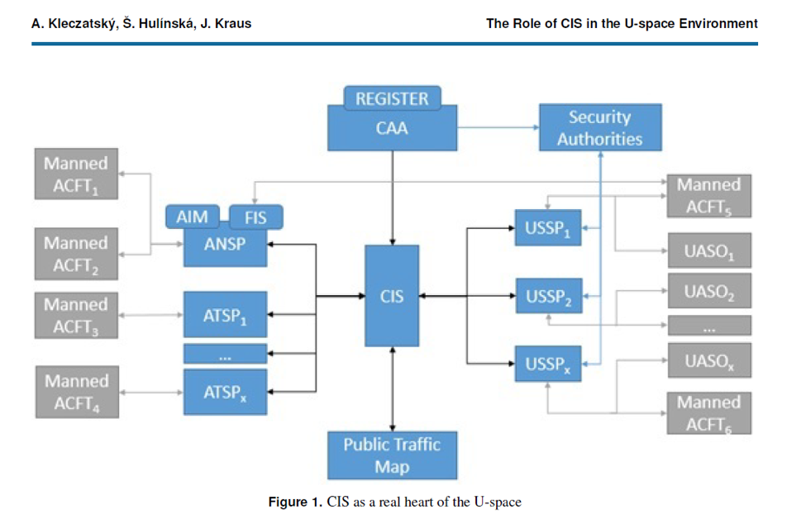
Decentralized configuration: 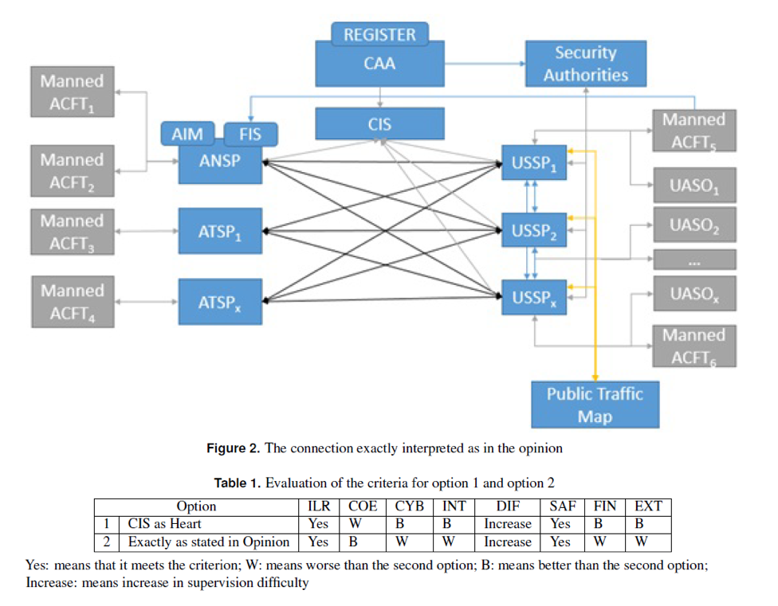
Where, as the research on this matter has recommended, there is room for both alternatives, and the one chosen should be the one best aligned with the regulator’s emphases, on the one hand, and the constraints and characteristics of the particular country, on the other hand.
    - All in all, the regulator should verify that all information needs are covered, for the sake of safe operation of air traffic, including:
      - Information concerning aviation risks:
        - Permanent airspace closures from the Aeronautical Information Publication.
        - Permanent airspace closures from the Air Force.
        - Temporary airspace closures (AIC and NOTAM).
        - Agriculture (spraying) aircraft.
        - Ultralight aviation.
        - Geographic Information System (GIS).
        - Powered Paragliding (PPG).
        - CVFR routes.
        - Low altitude helicopters – civilian and military.
        - Information from control towers.
        - Applications for flight authorization according to the shielding and monitoring procedure and/or various USSPs.
        - NCTR from control units, control centers, and other authorized entities.
        - Fast, low-flying aircraft in air force navigation routes.
      - Information concerning the ground:
        - Kindergartens, schools, open stadiums, synagogues, churches, and mosques.
        - Exposed large gatherings in real time.
        - Connection to municipality GIS systems.
        - Buildings over 15 stories high.
        - Population density maps, from the cellular providers.
        - Cellular network coverage.
        - Flight obstacles.
        - DTM and DSM.
        - Intercity highways with four lanes or more.
      - Information concerning potential GNSS obstructions / required coordination:
        - Police.
        - Strategic sites.
        - Negev Nuclear Research Center.
        - Shin Bet VIP protection unit.
        - Prime Minister’s Office.
        - Israel Prison Service.
        - Prison Authority.
        - Drone defense control centers.
        - Electronic (soft) warfare in the Air Force.
      - Current weather and forecasts:
        - Winds.
        - Rain.
        - Hail / snow.
        - Sandstorms / whirlwinds
        - Visibility / fog.
        - Cloudiness and synoptic maps.
        - Aircraft safety alerts.
        - Local weather.

Ideally, a total of about 40 layers of information are required, about 15 of them of higher importance.

The architecture illustrations are from an article of the Technological University of the Czech Republic:

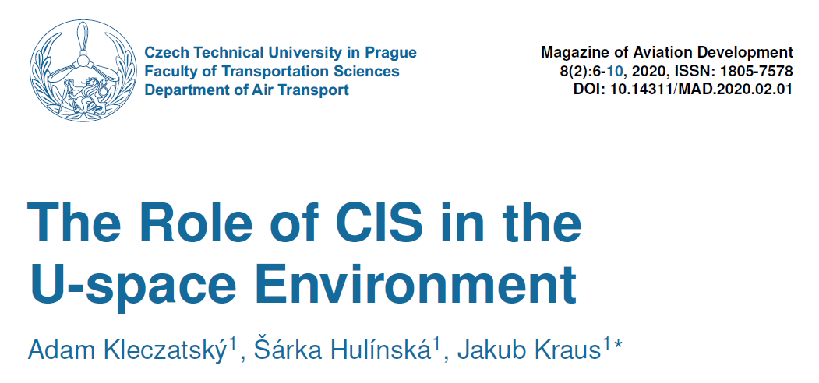
  - Flight operation document:
    - Regarding flights connected with the Initiative, all proposers shall undertake to perform them only according to the Flight Operation Document. This document is the source of authority / authorization to fly as part of the Initiative; hence, any flight not in compliance with the provisions of this document shall automatically constitute a deviation from the engagement, cancel the insurance, and serve as cause for termination of activity in the Initiative.
  - Experiment operation document:
    - Flights in the context of a well-defined test that is not a regular flight in the Initiative shall be performed based on the Experiment Operation Document. Any deviation from the terms of the Experiment Operation Document shall automatically serve as cause for termination of activity in the Initiative, and nullify the insurance, to the extent that the deviation was made within the Initiative’s time window and/or airspace.
  - Procedure for reporting safety incidents
    - Pursuant to the Aviation Law.
    - According to that defined in the company briefing document of Public Appeal 5185 (Reporting to the Initiative control center).
    - Recipients of the report shall guard the business interests of the reporting company.

- Annexes to rules of operation:
Annex A: Rules of BVLOS flights when operating Netivei Ayalon.
- Proposers must be familiar with the BVLOS documents as published by CAAI.
- Preference shall be given to proposers presenting a compliance matrix to BVLOS flight rules, operated by Netivei Ayalon as detailed in the company briefing document of Public Appeal 5185, including:
  - Operation through LTE cellular networks or satellite communication.
  - Telemetry update rate of at least once every three seconds or according to European standardization (autonomous flying is prohibited).
  - Ability to receive “land immediately” instructions from an authorized body and be on the ground within less than two minutes of notification, including definition of "Emergency landing spots" each kilometer along the track.
  - At least two GNSS receivers, capable of picking up at least three satellite constellations.
  - Ability to fly and land safely in the presence of GNSS reception interference, based on (at least one of the following, or by resorting to some other solution to be approved under the project):
    - Safe flying and landing capability according to video received via cellular device.
    - Navigation systems based on optical scene matching, within the envelope permitted for such a flight (three times height of buildings; not above sea, dunes, or similar).
    - A system of ground beacons installed by the proposer and/or based on cutting for cellular ground stations.
  - Commonly accepted mechanisms for incident responses in connection with loss of communication, and at least Return Home Mode (RTH).
  - A solution to different altitudes of ground between takeoff and landing points and/or surface with large changes of altitude should be provided.
  - A solution (technical or operational) for flight obstacles should also be provided.
Annex B: Characterization of landing strip infrastructure, definition of ‘landing strip operator’.
- Preference shall be given to proposers presenting a compliance matrix landing spot operation rule, operated by Netivei Ayalon as detailed in the company briefing document of Public Appeal 5185, including:
  - Obligation to define ‘landing spot operator’ in the sense that the landing spot will be “open for use to all companies”.
  - Default according to which the aerial operator is also the landing spot operator.
  - Solution for all aspects of regulating the use of the land.
  - Solution to all aspects of safety.
- If the proposer does not have access to the above document, he shall describe his proposal with reference to the regulations for operation of landing strips (of manned aircraft) issued by CAAI.

Annex C: Procedure for joining “crowded city square”.
- Proposers who are ‘aerial operators’ shall declare that they know the procedure, according to which, for eVTOLs, wherever there is a flight near people, a diagonal approach shall be preferred (or even spiral with continuous descent); thus, at any given moment, distance from the people will be greater than flight altitude.
- Proposers intending to operate eVTOLs shall specify the procedures recommended in order to reduce the risk toward the ground, particularly at the stage of descent to the landing spot or takeoff from it.
Annex D: Crossing of main intercity highways.
- All flights operated by the Initiative, regarding the crossing of intercity highways with over four lanes by eVTOLs/ drones, shall be carried out according to the procedure defined in the company briefing document of Public Appeal 5185 and, at least:
  - No more than 100 crossings a year for one operating company (and a total of up to 250 crossings a year).
  - Perpendicular to the highway, at as low an altitude as possible (no less than 20 meters, and preferably to greater than 50 meter), at high speed and without hovering.
  - It should be noted that in general, in proximity to such highways, there are different types of flight obstacles, particularly cellular antennae on high poles and high-voltage power lines.
  - Proposers intending to operate eVTOLs shall propose a suitable procedure for reducing the risk regarding vehicles on fast intercity highways.
Annex E: Characterization of the Metropolitan Drones Service Center including occupational analysis, screens, and interfacing organizations.
- With regard to proposers dealing in applications designed to be physicaly, within the Metropolitan Drones Service Center and/or interfacing with it, and/or interfacing with Air Force and/or Airport Authority operation centers and/or military and/or civilian control towers.
  - Preference will be given to proposers familiar with the conclusions of operations of Call for Partiicipation 5185 and present a compliance matrix relating to these conclusions.
  - Support of U-CTR
  - Support for operation of aircraft whose mission is limited to a certain polygon, including those operated with a ‘regular’ RF controller within eyesight (using an appropriate and mandatory application).
Annex F: Possibilities of flying in rough weather.
- Preference will be given to proposers familiar with the conclusions of operations of Call for PArtiiciipation 5185 and present a compliance matrix relating to these conclusions. At least:
  - Proposers shall relate to capability of operating simulations that support full interface with USSP.
  - Proposers shall relate to limitations of aircraft for flying in rough weather.
  - Proposers shall relate to procedure for flight up to maximum range of 50% range of actual visibility.

Annex G: Planning routs – principles for reduction of risk in general and toward earth in particular.
- Proposers that are aerial operation companies shall present their way of realizing “reduction of risk toward the ground, to the extent reasonable to realize”, according to that defined in the company briefing document of Call for Participation 5185.
Addendum A: Accumulated experience
Addendum B: Example from abroad
Addendum C: Method of defining NFZ from the aspect of risk toward the ground, in coordination with municipalities.
Addendum D: Population density maps according to aggregate information of cellular network companies.
Addendum E: Maps of cellular network coverage and ways of using them.
Addendum H: NCTR and integration of aerial picture of manned aircraft (including GNSS obstructions).
- Proposers that are aerial operation companies should show how they intend to present the picture of drones / aircraft entering the ‘drone bubble’, inter alia; preference will be given to whoever can present the conclusions of Public Appeal 5185 in this area. Proposers should relate to aerial picture of designated systems for protection from drones, Airport Authority / manned aircraft (BGA/ ACC south and north); aerial picture from Air Force. Connection to designated systems for detection and interception/downing of drones (ACCs, greater IDF, Police, Prime Minister’s Office, critical infrastructure). Agriculture (spraying) aircraft. Ultralight aviation Wheeled powered paragliders. Foot launched powered paragliders.
Annex I:
- Proposers should relate to how they intend to flight altitude, to serve also as common reference altitude (CORA) for USSP vertical separation. Preference will be given those who relate to Public Appeal 5185 conclusions.
Annex J: Automatic evacuation of the airspace for manned or prioritized flights.
- Proposers that are aerial operation companies should show capability of landing within two minutes from receipt of notice.
- Proposers shall be in charge of planning a landing point each kilometer along the routes used by them.
Annex K: Statistics as basis for Data Driven Regulation (DDR).
- Proposers dealing in USSP and/or CIS should show which statistics and logs they intend to keep.
- Logs should be kept for at least three years.
- Preference will be given to those who implement the conclusions of Public Appeal 5185 in general and in a way that supports DDR in particular.
Annex L: Procedure for flight in area supervised by control tower – Eitan Procedure.
- Preference will be given to companies familiar with the Eitan Procedure, and can declare that they will comply with it.
- The procedure enables flights within TMA without coordinating with BGA, given CAAI approvals and flight at altitude at which there are buildings higher than flight altitude, between the drone and BGA, thus creating ‘shading’.
- The procedure is valid only for companies under CAAI-approved USSP monitoring.
Annex M: USSP/MDOS architecture and communication protocols (including communication between USSPs and definitions for CIS).
- Preference shall be given to proposers capable of adapting to the architecture determined as part of Public Appeal 5185.
Annex N: Retainment of knowledge, flow of knowledge and sharing of knowledge in real time.
- All proposers shall participate in the knowledge retainment architecture of the National Drone Initiative, including Google Sheets, an event diary, registration sheets including aircraft registration numbers, company permits, flier permits, insurance policies, and documents of obligation towards municipalities that require them.
Annex B: Way of writing response.
- The response shall be submitted as a Word/PDF document, attached as an annex to the submission on the Innovation Authority website.
- The response shall include, at least, the following chapters:
  - Chapter 1: A description of the components that the proposer plans to provide a solution for and/or declaration of which areas he intends to deal in, as divided into areas of relevant technological applications, as follows:
    - Area 1: Development, production, import and assimilation of platforms that have never before flown in Israel, as part of Public Appeal 5185 or other operations by Netivei Ayalon / National Drone Initiative. This refers to aircraft that have not yet been given license or permit for operation in Israel; aircraft that advance the Initiative with regard to maximum range/ payload and/or innovative application. This area should include detailed reference to procedures for import, customs, Ministry of Communications approvals, CAAI approvals, process of application for permits – for the aircraft, operating company, and flier / operator. It is recommended to relate explicitly to the following:
      - UAVs (including unmanned eVTOLs): Whether this refers to an eVTOL or UAV whose weight upon takeoff is 25 kg or more, up to 150 kg or more, and whether it is already licensed in the USA or Europe.
      - Manned or optionally manned aircraft: eVTOLs capable of carrying people with pilot or future possibility without pilot and/or freight carrying, such whose weight at takeoff is usually well over 150 kg, referring to aircraft whose maximum weight at takeoff is in the order of several tons, capable of carrying an effective weight of 150 kg or more and/or capable of carrying 2-12 passengers.
    - Area 2: Interfaces and regulation development support between organizational bodies, and different levels of applications.
    - Area 3: Proof of delivery (POD) to a defined person
    - Area 4: Actions required for defining requirements, development, procurements, assimilation, and proof of cyber protection of the ecosystem components.
    - Area 5: Operation of landing spots/ Vertiports for heavy UAVs / eVTOLs
    - Area 6: Civilian NCTR systems.
    - Area 7: Operation of one or more of the above areas (from aspects of skilled manpower and its recruitment, training, certification, operation, etc.).
  - Chapter 2 – Familiarity with the regulatory content world:
    - Proposers shall detail the regulation commonly applied in Israel, the EU and USA pertaining to the area he intends to provide a solution for and declare which regulation he is familiar with and include, if needed, reference to relevant documents. In connection with Israeli regulation, proposers should at least refer to that detailed in the Public Appeal.
  - Chapter 3 – System description/proposed service:
    - This chapter should include a detailed ‘technical response’ including description of the system, subassemblies, components, processes, etc. A functional description, description of interfaces with the external environment of the topic addressed, and any other topic that will make it easier for the examiners to understand the proposer’s intentions, as well as the requested budget. Special emphasis should be placed on providing solutions for the following:
      - In connection with Area 1 – development, manufacture, import and/or assimilation of aircraft that have not yet flown in Israel:
        - How to form a common ‘licensing basis’ with CAAI, how long it is expected to take and what regulation and standards the proposer wishes to use. It is highly recommended to use benchmarking with regard to similar processes already performed abroad. How long the processes of contacting the manufacturer, import, release from customs, and performing a test plan with CAAI are expected to take. Attention should be given to:
          - Airworthiness requirements along All aviation professions (structural strength, static and dynamic loads, proof of reliability, resistance to environmental conditions, etc.).
          - If the ‘performance based’ approach is being taken, what process will be used to build the proposed level of confidence – how many flights, which aircraft have already undergone by the manufacturer or elsewhere, etc. What is the enabling regulation (SORA will be the default, according to EU regulations).
          - If the ‘Type certificate' direction is chosen – what regulation will be relied on/ which obligating documents/ standards will be used (for example, STANAG 4738).
        - If bringing a manned aircraft with pilot and/or designed to carry passengers:
          - Will it be possible to fly it as a UAV, and if so, under what regulation?
          - Does it have or when is it expected to have a type certificate? Who is supposed to issue the certificate, and what is the expected process of adoption in Israel?
        - ‘Content of work’ tables should be provided, including detailed technical characterization, experiments, ‘development blocks’/milestones, resources, and budget requests.
        - A risk plan should be provided.
        - Technological preparedness should be presented, according to requirements of Public Appeal TRL7 and up.

      - With regard to Area 2: Interfaces between organization and/or applications:
        - Development of system and procedures enabling planning and submission of flight plan, in areas supervised by civilian and military control towers, including automatic receipt of permits and real-time receipt of constraints in actual stages of flight.
        - Development of system and procedures between the U-Space world and USSP world to the Israel Airports Authority and various control towers (including as required ACC north and south, BGA, Ramon Airport at Timna, and all smaller airports and landing strips in Israel).
        - Completion of development and adaption of USSP systems for the regulation being developed in the EU/ USA – beyond that developed and demonstrated in Public Appeal 5185. Includes practical use of DSS (Detection and Synchronization Services) as defined in Standard ASTM 3411.
        - Development of protocols and standards pertaining to receipt of information from the ‘national CIS’ (pending set-up of National CIS, temporary substitute capabilities must be made available at the minimum functional level required for running the various processes) and its distribution to the various USSP, and from them to the MDOS of the operating companies, while responding to as many layers of information as possible, including:
          - Airspace closures originating in permanent civilian aviation infrastructure, based at least on the Aeronautical Information Publication.
          - Temporary and/or dynamic airspace closures originating in the Air Force, Airports Authority (such as NOTAM or AIC) or other bodies that could be sources of dynamic closures such as the Police (when launching helicopters, MDA, etc.
          - Weather (including winds, precipitation, visibility, fog, current state, and forecasts, etc.).
          - Aerial picture produced by the Airport Authority and/or Air Force.
          - Buildings over 15 stories high.
          - DTM and DSM.
          - Flight obstacles.
          - Aerial picture, regarding very low altitude, of entities that are not in cooperation with the USSP.
            - Amateur drones, and other unidentified drones.
            - Agriculture (spraying) aircraft.
            - Helicopters in general, and those on CVFR routes.
            - Air traffic in CVFR.
            - Ultralight aviation.
            - Geographic Information System (GIS).
            - Powered Paragliding (PPG).
          - Cellular network coverage
          - Population density maps based on cellular networks.
          - Ground closures based on:
            - Mass gatherings.
            - Gatherings of exposed people.
            - Mosques, churches, and synagogues.
            - Kindergartens and schools, and at places of assembly such as open playing fields, during practice or a game.
            - Stadiums during performances or games.
            - Sites suspected of potentially obstructing GNSS, or such that operate such obstructions.
        - Development of protocols and standards regarding uploading data to the national CIS, including:
          - Overall aerial picture.
          - Licensing data of each operating company including certifications and validity.
          - Licensing data of each flier including certifications and validity.
          - Licensing data of each aircraft/ scenario including validity.
          - How to guarantee the validity of the above data to conditioning of flight authorization/ system login.
        - Enhancement and completion for communication between USSPs based on Public Appeal 5185 conclusions, developing regulation in EU/USA including reference to GUTMA and ASTM standards. The proposal should include support in the following matters:
          - Uniform standard for all companies operating in Israel.
          - Support for ‘Roaming’ capability – in other words, a state in which the UAV operator can communicate with any USSP it wants, and still fly anywhere a ‘UAV bubble’ has been defined, in configurations of neighboring and/or overlapping USSPs, and/or define itself as a USSP, and all coordination required is done transparently for the aerial operator / MDOS.
          - Enhancement of completions regarding communication between USSP and MDOS, bringing it to a state of uniform standard supporting full migration capability from one company to any other.
          - Development, productization, assimilation, proof, and realization/ enhancement and completion for a IT system supporting the ability to coordinate the prevention of GNSS disruptions with all bodies having any connection to this matter, including:
            - Electronic (soft) warfare in the Air Force.
            - Air Force control stations.
            - Critical installations.
            - Prime Minister’s Office (including the three relevant branches).
            - Police.
            - Israel Prison Service.
            - Chief Communications Officer Command and various EMC and EW bodies.
            - Any other/ additional relevant body.
          - Development, productization and proof of technical procedures and protocols for support of flight clearance requests and managing the flight itself, when the flight is carried out in VLOS (including possibility of small/ amateur aircraft, inter alia, through application on controller, with the app communicating with the USSP. Proposers offering solutions to this component should at least comply with the American LAANC procedure, particularly the ability to realize support in VLOS as stated, even when flying under civilian or military regional control and/or under supervision of civilian or military airfields.
        - ‘Content of work’ tables should be provided, including detailed technical characterization, experiments, ‘development blocks’/milestones, resources, and budget requests.
        - A risk management plan should be provided.
        - Technological preparedness should be presented, according to requirements of Public Appeal TRL6 and up.
      - With regard to Area 3: Proof of delivery (POD) to a defined person
        - Analysis of ‘economic verticals’ required for POD.
        - Architecture proposed for the support of each vertical, at least in connection with the distribution of medications, mail, registered mail, medical equipment, blood samples and products.
        - Detailed description of the proposed system including breakdown into ‘blocks’ and estimation of the time/ budget for each ‘block’. The description should include detailed reference to eVTOLs/ UAVs, their sensors, prevention of forgery, authentication, biometric identification, challenges of privacy laws, etc. including details of all regulators in each vertical, and how the proposer intends to create a regulation process vis-a-vis the regulators for approval of use in the proposal.
        - Explicit reference should be made to the question of identification versus the need for anonymization of databases as well as privacy law and information security aspects.
        - Proposers shall analyze an alternative of establishing a national POD system, serving all verticals.
        - Preference to utilization of proven, existing capabilities in widespread use. Preference for solutions without addition of new physical elements.
        - ‘Content of work’ tables should be provided, including detailed technical characterization, experiments, ‘development blocks’/milestones, resources, and budget requests.
        - A risk plan should be provided.
        - Technological preparedness should be presented, according to requirements of Public Appeal TRL6 and up.

      - With regard to Area 4: Actions required for defining requirements, development, procurements, assimilation, and assimilation of cyber protection of ecosystem components:
        - Relevant standardization should be noted.
        - A description should be given of the process of what is planned to be done, including TARA, analysis of players, tools, methods, protection assets, deployment of attack vectors/trees, and proposal what should be dealt with and how.
        - A description should be given of how to ensure continuous cyber protection in the future, including periodic audits, continuous monitoring tools such as SOC, human-based penetration testing and/or use of similar automatic system, etc.
        - Details should be given of the interface between the proposer and the manufacturer of the system he intends to protect and/or its operator.
        - The description should include aspects of regulation, benchmarking, and what is offered in Israel.
        - ‘Content of work’ tables should be provided, including detailed technical characterization, experiments, ‘development blocks’/milestones, resources, and budget requests.
        - A risk plan should be provided.
        - Technological preparedness should be presented, according to requirements of Public Appeal TRL6 and up.

      - With regard to Area 5: Operation of landing spots/ Vertiports for heavy UAVs / eVTOLs
        - A plan of action should be given, aimed at leading the matter to regulatory approval.
        - Details of the ‘plan’ should be given, including aspects of ‘soil stain’ area, description of operation (number of aircraft supported, number of takeoff and landing stations, number of loading/unloading passenger boarding stations, size of terminal (if required), size of warehouse (if required), size of offices, to the extent such are required). Water, sewage, and power infrastructures. Routine of activity from aspect of arrival at landing strip, operation of flight control in landing strip area, and provision of full services as required for operation of landing strips, etc.
        - A full plan should be given for the construction of two or more landing strips and at least three years of operation under a BOT mechanism.
        - The plan should relate to international benchmarks and include reference to landing strip regulations as well as the chapter on landing strips in the Netivei Ayalon company briefing document.
        - ‘Content of work’ tables should be provided, including detailed technical characterization, experiments, ‘development blocks’/milestones, resources, and budget requests.
        - A risk plan should be provided.
      - Area 6: Civilian NCTR systems.
        - A review should be made of existing systems in Israel and around the world.
        - A solution should be proposed for coverage of the area around:
          - A track 25 km long with at least one minute’s notice for approach of aircraft not belonging to USSP toward the track, in a way that could endanger aircraft receiving USSP service.
          - Protection polygon of 2x2 km with requirement of two minutes notice for approach of aircraft not part of USSP and which could endanger the site within the polygon.
        - The required warning is for aircraft whose maximum speed is 25 knot and have a radar cross-section and acoustic, optical and signal intelligence signature like Matrice 300.
        - Do not relate to active defense or soft defense.
        - The solution should support migration capability at time constants of a few hours.
        - Details should be given whether the proposed solution has already been used, in Israel or in general, which customers and what scope.
        - If the proposed solution is radar-based, details of EMC should be given, and allocation of civilian frequencies in Israel, including ways of obtaining permits from the Ministry of Communications.
        - Systems that are designed to ‘detect’ only DJI products will not be taken under consideration.
        - Evaluation preferences will be independent of the type of aircraft and/or new types entering the field.
        - ‘Statement of Work’ tables should be provided, including detailed technical characterization, experiments, ‘development blocks’/milestones, resources, and budget requests.
        - A risk plan should be provided.
        - An outline of a business plan should show the global market potential of at least tens of millions of dollars within five years of commencement of the Call for Participation.
        - Technological readiness should be presented according to this Call for Participation requirements to be TRL6 and up.
      - Area 7: Operation of one or more of the above areas (from aspects of skilled workforce and its recruitment, training, certification, operation, etc.).
        - According to the areas noted above, an indication should be given of the area in which the proposer wishes to deal.
        - The description should be given of methods of workforce recruitment, training, certification, and retainment over time, for each ‘profession’ separately.

Discovery and Synchronization Services
Algorithm designed to calculate ‘weekly credit’ with regard to being late / ordering of unutilized resources, and a way of taking them into account in future prioritization of resource allocations.
Through the air control units.
Through the association app.
Through the association app.
Through the air control units.
Military and civilian.
From municipalities.
Perhaps from Survey of Israel.
Probably from Survey of Israel.
Assuming that there will be such, or a simulation of such, at the time the Public Appeal is published.
This matter has not yet been regulated as far as the aerial picture and information security are concerned.

